(Approx. 1834 words)

Uninterruptible Power Supplies
By Dick Maybach, Brookdale Computer User Group
www.bcug.com
n2nd (at) att.net

An Uninterruptible Power Supply (UPS) is a box that plugs into a power outlet on a wall into which you plug in your computer and its key peripherals. You connect it the same way you connect a power strip. Inside the box is circuitry that monitors the AC voltage, a lead-acid storage battery, a charger, a power supply that converts the battery voltage to 60-Hz ac line power, and a switching circuit that selects whether your computer is powered from the wall or the battery. Most units also include a surge suppressor. Normally, your computer and its peripherals are powered from the wall, and the UPS battery is charged, but if the AC voltage becomes too high or too low, the battery powers your devices through the AC converter.

Power companies in the U.S. provide reliable service, but sometimes this isn't easy. For example, they use the earth as part of their circuit, partly for safety reasons (to avoid high voltages building upon their wires). Service is difficult to maintain if the resistance of the earth is high, as is the case in the Freehold, New Jersey area, where I once was responsible for a lab. Partly as a result of this experience, I always used a UPS with my work computer. I saw the lights blink more than once, followed by streams of profanity from nearby offices where computers had crashed because they weren't UPS equipped. Although there may be no economic impact resulting from a power glitch while working on a home computer, it is most frustrating to have an editing or photo-retouching session ruined or an operating system corrupted by a power glitch during an update. Modern UPS units are cheap, and life is short, which often makes investing in one well worth its cost.

A surge protector has a device that is connected across the power line. If the voltage rises above a specific value, the resistance of the device becomes low. The hope is that the device will survive long enough to keep the voltage low until the surge is over. Most such devices will protect against one surge, but in doing so, they burn out, which is why many surge protectors have an indicator that is illuminated if the device is good. Of course, since most of us locate our surge suppressors on the floor with the dust bunnies, we can't see their indicators. Surge protectors do not protect from low voltages.

By the way, neither surge protectors nor UPS units can defend against direct lightning strikes, which can vaporize the wiring in your house as well as equipment connected to it. The voltages are high enough for lightning to arc hundreds of feet from a cloud to the ground, and the currents can be a million Amperes or more. Fortunately, direct strikes are rare. However, a lightning strike near the power grid can cause a momentary rise in the voltage, which is what a surge protector tries to prevent.

Most consumer UPS devices have the architecture shown in Figure 1. First, the Protected AC Out socket is connected through the AC In cord to a wall outlet in normal operation. At the same time, the input power is applied to a battery charger that keeps a lead-acid battery (which uses the same chemistry that starts your car) fully charged. Finally, control circuitry monitors the AC-In voltage. If it departs from what is acceptable, a relay switches Protected AC Out to a DC-to-AC converter that generates a 125 volt, 60 Hz waveform from the DC voltage on the battery. This does mean that the Protected AC Out voltage is zero during the time it takes for the relay to complete its operation. Still, this time is short compared to the 1/60 second period of our power system, and it doesn't affect a computer's operation. In addition, most UPS devices have additional outputs connected to the AC In port through a surge protector.

A push-button connects to the controller. When it turns off the UPS, Protected AC Out is turned off, but battery charging continues, and Unprotected AC Out remains hot. The last is important; to avoid unpleasant surprises, be sure to unplug any unprotected devices before working on them.

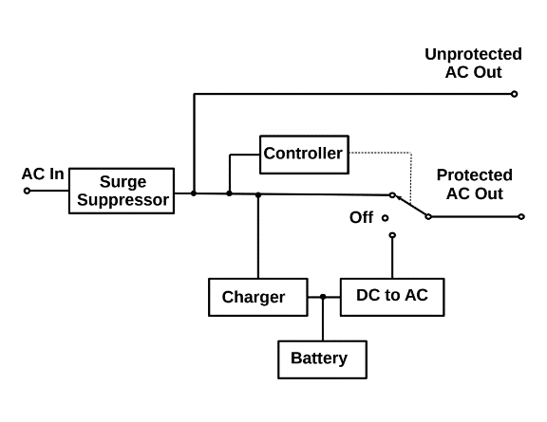

Figure 1. UPS Architecture.

Some iMacs are incompatible with some popular UPS units. They work fine when the ac power is good, but the UPS will refuse to switch to battery when it fails. So if you have an iMac, do your homework.

Try to buy your UPS from a supplier that offers a "No questions asked" return policy on UPS purchases; not all do (in particular, Amazon the last time I checked). As soon as everything is connected and the battery is fully charged, pull the ac power plug to see if the unit switches to battery power. If it doesn't, you should trade it for a compatible one.

A UPS is designed to provide power when that from your power company fails. In particular, it assumes that commercial power is available when it's first turned on, and it may not start if this isn't true. This means you may not be able to use a UPS to provide power on a camping trip. You also may not be able to turn it on after the power fails.

Most UPS manufacturers specify the maximum output of their units in both Watts and Volt-Amperes, with the latter being larger. You should buy one with a maximum Wattage equal to or larger than your computer power supply rating. (We're discussing here only the total power supplied by the battery backup connectors; we can ignore the power supplied by the surge protected connectors.) I'm assuming that you purchased your computer system and that the manufacturer correctly sized its power supply. Make appropriate adjustments if you know you have a larger than necessary supply, which is usually the case if you built your system. The average power consumed by your computer is usually significantly less than its maximum power supply rating. We have to be concerned about the maximum because the UPS will shut down if you try to draw more than its rated power from its battery backup connectors.

To estimate how long you can run on battery power, you have to know the average power consumption of your computer. My desktop uses about 100 Watts, which is probably a good starting point, although I would double this for a game machine with a high-power display driver. If you're still using a CRT monitor, you should probably add 25 to 50 Watts for that. Some manufacturers, including APC, have graphs on their websites showing run time vs. load, although these are valid only for new batteries. Many USP manufacturers specify the length of time they can supply power at maximum load, and you can use this to estimate how long they will last. For example, my UPS is rated at five minutes at 600 Watts. Therefore, at 100 Watts, it should last six times as long, or 30 minutes. APC's chart shows 50 minutes at 100 Watts, so the rough estimate is comfortably conservative and allows for battery aging.

Decide what you want to keep running when the power fails. Your goal is to keep your computer running long enough so that you can save your work and power down normally. You may be able to work for a little while, but once the battery is exhausted, you're done. At a minimum, you need to back up your system unit and display. If you are visually impaired, you should also include your powered speakers. Everything else should have just surge protection; this includes your printer, scanner, and network equipment. It is especially important that you not try to back up a laser printer, as they draw so much current that your UPS may not turn on, even when your house power is normal.

Figure 2 shows the rear panels of two American Power Conversion UPS devices. Both have two cable-TV and two Ethernet connectors connected to surge suppressors. Both also have a USB connector, which allows your PC to monitor the UPS. The left one has two types of outlets labeled Battery Backup and Surge; the left-hand connectors are UPS protected, and the right ones have only surge protection. The unit on the right is more complex. The top protected connector has the label Master. When current flows from this socket, the sockets labeled Controlled by Master are also turned on. And when the current stops flowing from the master socket, those controlled by it are turned off. I connect my PC to Master, my monitor to Battery Backup Controlled by Master, and my speakers to Surge Only Controlled by Master. As a result, when I turn on the PC, the monitor and speakers are also turned on. However, if the power fails, only the PC and monitor remain powered. My other peripherals, the printer, and scanner are neither controlled by the PC nor protected. Inkjet printers should always be turned off using their own power switches, which is controlled. Just pulling the plug can result in ink clogs.

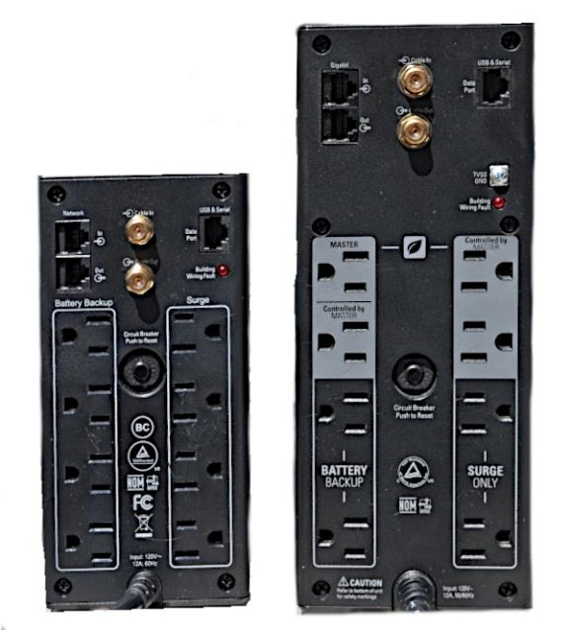

Figure 2. APC UPS Rear Panels.

Many UPS units have associated software that allows you to configure them and monitor their operation. It may also include a provision to shut down your computer if the battery becomes depleted during a power outage. However, UPS manufacturers are Microsoft-centric; their software may be Windows only, and if it does have Mac or Linux software, it probably has fewer features than the Windows version. Some higher-end units include front panels that provide much of the software's monitoring, which makes them less reliant on your operating system.

Figure 3 shows a Linux monitoring screen. It shows that the battery is fully charged and will power the system for about 53 minutes at the current load.

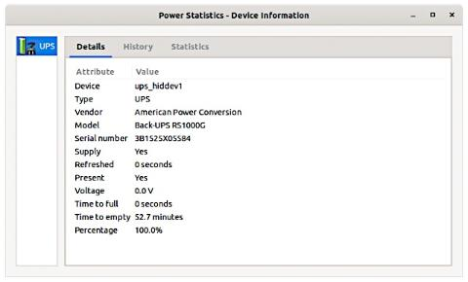

Figure 3. Linux UPS Monitoring.

The built-in Windows program that checks the battery is even terser, Figure 4.

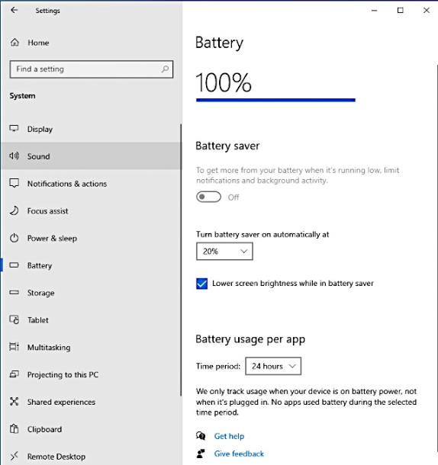

Figure 4. Windows Battery Monitor.

Windows users can install APC's Power Chute software to get a better view PowerChute Personal Edition - APC USA. The following screen-shots are from this program. Figure 5 shows the current status.

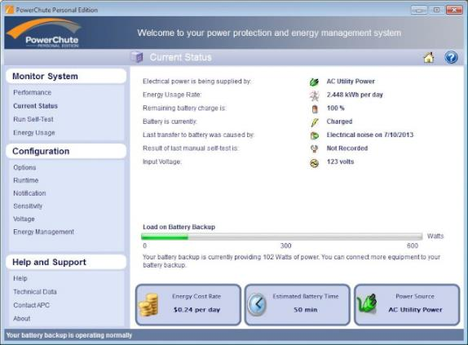

Figure 5. Power Chute Window Showing Current Status.

Figure 6 shows the voltages that cause the UPS to switch over to battery power.

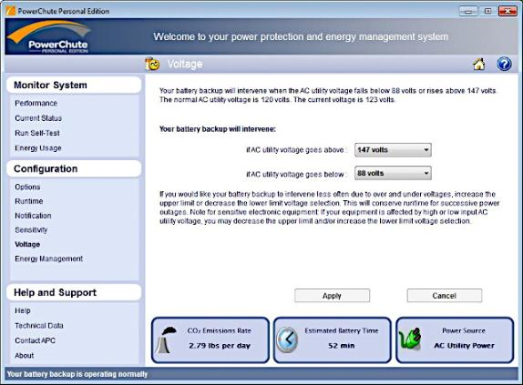

Figure 6. UPS Voltage Settings.

Figure 7 shows the power drawn from the master outlet, resulting in the other connectors being shut off.

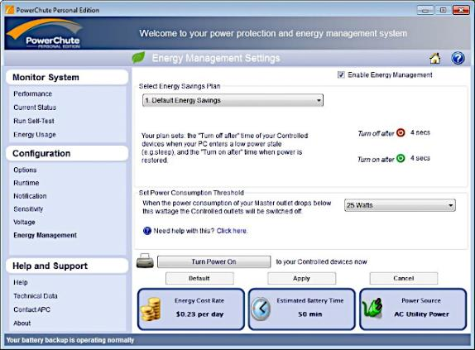

Figure 7. Shutoff Control Power.

By the way, you can purchase smart outlet strips that claim to control power in this way. However, I've found that their threshold is far too low to make them usable with PCs. PC system units draw a little power even when off, and it's sufficient to keep a smart outlet strip on.

Regardless of its features, a UPS is a valuable peripheral that can save you much time and frustration.

